**Union Bank of India Ranks 2nd Runner up in EASE 7.0 Reforms Index for FY 2024-25**

***Mumbai- 4th July, 2025***: Union Bank of India, one of India’s leading public sector bank, has been declared as 2nd Runner up in EASE 7.0 Reforms Index for FY 2024-25. Further, the Bank is amongst the top performers in the following three themes of EASE 7.0 Reforms Agenda.

1. **1st Position**: Banking towards Viksit Bharat
2. **1st Runner up**: Effective Risk/Fraud management, Collections and Recovery
3. **1st Runner up**: Developing employees for emerging banking priorities

Shri M. Nagaraju, Hon’ble Secretary, Department of Financial Services, Ministry of Finance, felicitated the Bank at the citation ceremony organized by the Indian Banks’ Association (IBA) in Mumbai on 03.07.2025

Enhanced Access & Service Excellence (EASE) is an initiative by the Department of Financial Services, Ministry of Finance, Government of India as part of the PSB Reforms Agenda. The Key priorities of EASE 7.0 were Banking towards Viksit Bharat, Excellence in Customer service, Adoption of new-age technology and other advanced capabilities, Effective Risk/Fraud Management, Collections Actions, Recovery and Developing employees for emerging banking priorities.

Identification and development of focus economic sector, Availability of AI-conducive policies and governance system in the bank, Analytics setup to trigger calls to customers in pre-delinquency stage, Availability of mechanism to track branch performance on customer experience, Availability of digital portal to track all legal proceedings and online OTS portal with recommended functionalities and Degree of digitization in Staff loans have been identified as the key areas of strength for our Bank .

Union Bank of India has been consistently ranked amongst the top performers in EASE Reform Index over the years for effectively implementing the reforms measures and initiatives.

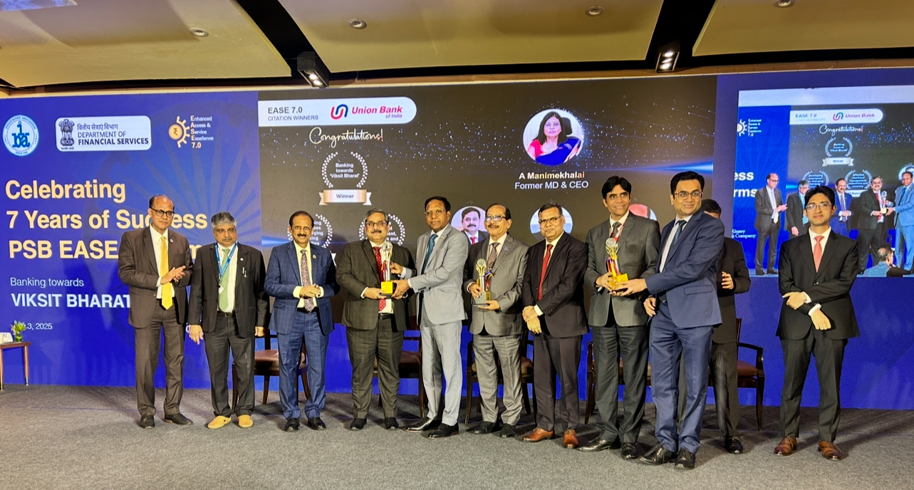

[From left to right: Mr. Ashwini Kr. Tewari (MD, SBI), Mr. A K Goel (Chief Executive, IBA), Mr. C S Setty (Chairman, SBI), Mr. Nitesh Ranjan (Executive Director, Union Bank of India), Mr. M. Nagaraju (Hon’ble Secretary, Department of Financial Services, Ministry of Finance), Mr. Sanjay Rudra (Executive Director, Union Bank of India), Mr. Anil Kuril (CISO, Union Bank of India), Mr. Tata V. Venugopal (CTO, Union Bank of India), Mr. Avinash Prabhu (CFO, Union Bank of India) Mr. Ashish M More (Joint Secretary, DFS) and Mr. Rohan Chand Thakur (Director, DFS)]